**3d. Seed Energy**

Seed Energy (SE) refers to the energy embodied in seed production. It is calculated based on the seeding rate for the crop and values in Table 10 that indicate the amount of energy required to produce seed per unit of crop output. These values are derived from the Field to Market National Indicators Report and based on the assumption that the energy use required for seed production is approximately 150% of the energy required for commercial crop production.

Note that for alfalfa, the final metric should be divided by the number of years of stand life. As seeding only occurs once for the life of the stand, this amortizes the energy across the years.

REVISION HISTORY

07-09-2018 – revised to clarify how to handle different unit inputs (added step 2A)

08-30-2018 – revised to clarify how to handle different unit inputs and how to handle potatoes (removed step 2A from 07-09-2018 and added 3A and 3B)

|  |
| --- |
| **User Inputs:** |
| Yield (*Y* or *Yi* if irrigated) |
| Crop Type |
| Seeding rate per acre (SR) (will be specific to each crop) Table 4 |
| If crop is alfalfa, the expected stand life (ESL) in years |
| **Additional Information needed:** |
| Crop specific seed embodied energy (in BTU/seed or BTU/cwt(potato) or BTU/lb (alfalfa) Table 5 |
| Seeds per crop output measurement Table 5 |
| Energy Use Indicator Average per crop output Table 6 |

**Calculation of Seed Energy**

Step 1: Draw energy value from Table 6’s “Energy use Indicator Average” column for the identified crop type.

Step 2: Divide Step 1 value by “seeds/crop output measurement” value from Table 5.

Step 3:

3A: If seeding rate units are entered in seeds/acre proceed to 3B; if units are in weight of seed per acre, first multiply the seeding rate by the "seeds/lb" column in Table 5 (see Example #3); if crop = potatoes, first multiply the seeding rate by both the “seeds/lb” column in Table 5 and the “lb./crop output measurement” column in Table 5 (see Example #4).

3B: Multiply Step 2 value by the seeding rate (select midpoint via Table 4)

**SE**= total seed energy/acre

|  |
| --- |
| *Alternative Step 3: If crop is alfalfa, calculate* ***SE*** *as total seed energy per acre per year = ((total seed energy/acre)/ESL)* |

Step 4: Calculate **SEy** as total seed energy per acre divided by yield (SE/Y)

|  |
| --- |
| *Alternative Step 4: If crop is alfalfa, calculate* ***SEy*** *as total seed energy per acre divided by yield (SE/Y)* |

**Example #1:** A grower would like to know the amount of seeding energy associated with planting soybeans at a rate of 170,000 seeds/acre, producing a yield of 60 bu/acre.

Seeding energy (**SE**) = 65,338 BTU per bu / 150,000 seeds per bu

= .44 BTU/seed*162,500 seeds/acre planted

= 70,826 BTU per acre

**SEy**= SE/Y = 1180 BTU/bu

**Example #2**: An alfalfa grower in year 3 of a five year stand needs to include the relevant portion of seed energy. They achieve a yield of 3.2 tons/acre in year 3 and the seeding rate was 15 lbs/acre.

**SE** = 

**SEy** = 170,994 BTU/ 3.2 = 53,436 BTU/ton for year 3

**Example #3:** A peanut grower would like to know the amount of seeding energy associated with planting peanuts at a rate of 110 lbs/acre, producing a yield of 6540 lbs/acre.

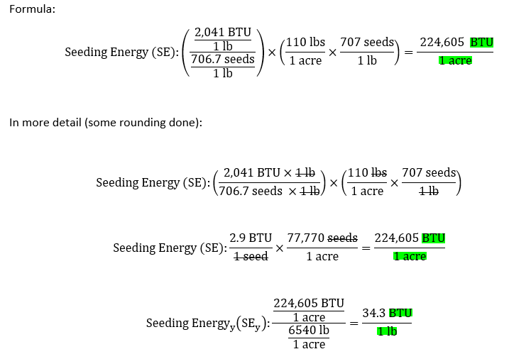

**Example #4:** A potato grower would like to know the amount of seeding energy associated with planting potatoes at a rate of 29 CWT/acre, producing a yield of 400 CWT/acre.

